## La Corona dataset –Pair catchment sites (2000-2022)

## Lumin SA-North Carolina State University (NCSU)

## Summary of shared data

## 

La Corona station is the result of a multi-national research project initiated in 2000 with the aim of studying the environmental impacts of afforestation and forest management in Uruguay. This paired catchment study was set up initially to quantify the hydrologic impacts of converting grazed grasslands to pine plantations. From 2000, outflow and weather data were collected during a three-year pre-treatment period when land use of both control (69 ha) and treatment (108 ha) catchments was native grassland with livestock grazing. The treatment catchment was planted to *Pinus taeda* in July 2003 while the control catchment remained in grassland. (Phillips, 2018)

## La Corona Data folder (Contents)

**Documents**

_Paper von Stackelberg et al 2007 (Chescheir, Skaggs, & Amatya, 2007)

_Thesis von Stackelberg et al 2005 (VON STACKELBERG, 2005)

**Field data**

_Flumes V1V2, daily 20 years .csv (looks like curated data, pine and pastures pair)

Data:Date, V1(mm), V2(mm), Rain(mm), PET (mm)

**SWAT inputs of von Stackelberg**

_SWAT inputs from the model of the paper 2007

**GIS**

_shapefiles of the catchment, area, monitoring points, camineria, native vegetation, fences, flumes and other instruments, satellite images.

### Study area

Figure 1 shows the map of the station and the 4 Pine (V2), Pasture (V1), Pasture (V3) and Eucalyptus (V4) catchment.

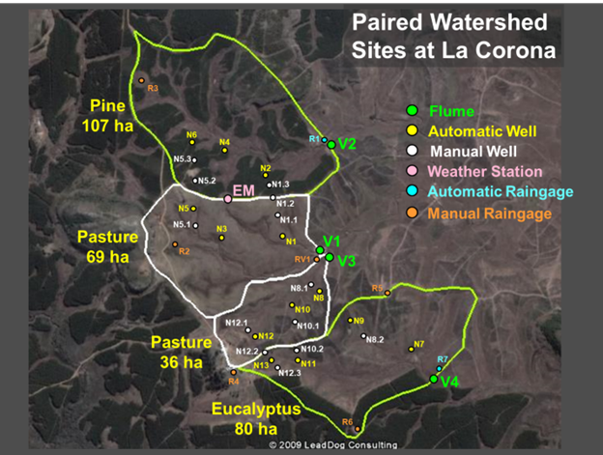

Figure 1. Locations of data collection points at the La Corona watershed sites. (author: George Chescheir)

The following images in .jpg are available in the folder (see annex)

| N° | Nombre del archivo | Descripción |
| --- | --- | --- |
| 1 | UruguaySite2 | Mapeo de área del sitio de la estación |
| 2 | La_Corona_Subzona_B1 | Imagen de subzona B1 2008 |
| 3 | La_Corona_Subzona_A1 | Imagen de subzona A1 2008 |
| 4 | FotoCorona_223 138b | Imagen 2008 |
| 5 | UruguaySite1 | Pin de localización de la estación 2008 |
| 6 | Cuencap1 and Cuencap2 2008 | Imagen cuencas pasturas en 2008 |

## Treatment catchments V1 and V2

Table 1 describes the treatment of basins V1 and V2 since 2000 to be considered for the analysis using hydrological data.

Table 1. Treatment in Pines and Pastures catchments

| Period | Activity | Comments |
| --- | --- | --- |
| 2000 -2002 | Pre-treatment (3 yr) | control (69 ha) and treatment (108 ha) catchments was native grassland with livestock grazing. |
| 2003 | Planting | The treatment catchment was planted to *Pinus taeda* in July 2003 while the control catchment remained in grassland. (Phillips, 2018) |
| 2003- June 2013 | Growing  Thinned and pruned in June 2008  Pruned again in June 2011 | Hydrology data collection has continued for both catchments  10-year treatment period |
| 2013-2022 | Growing | 10-year period |
| 2022 | Harvest planned |  |

## La Corona Instrumentation data, *Form: George Chescheir, NCSU*

**Instrumentation at La Corona sites**

Refer to Figure 1

**Flumes**

V1 and V2 1.37 m HL Flumes (see Figure 2)

V1 - Stevens Recorder with Hobo U12 datalogger on potentiometer in stilling well

<https://www.onsetcomp.com/files/manual_pdfs/13125-B%20MAN-U12006-web.pdf>

Example file name from field <v1090418.hobo> <v1090418.csv>USB

S1 - Hobo U20 Pressure transducer in outside well

<https://www.onsetcomp.com/products/data-loggers/u20-001-04/>

Example file name from field <s1090418.hobo> <s1090418.csv>LANZADERA

Sampler -

<https://www.teledyneisco.com/en-us/water-and-wastewater/6712-sampler>

Isco 720 pressure transducer in stilling well connected to sampler

<https://www.teledyneisco.com/en-us/waterandwastewater/Pages/720-Module.aspx>

Example file name from field <v1090418csv.csv>SERIAL

E1 - Emergency Spillway – Broad crested weir with U20 Hobo Pressure transducer in stilling well

Example file name from field <e1090418.hobo> <e1090418.csv>LANZADERA

V3 and V4 Triangular Flumes (see Figure 3)

V3 - Stevens Recorder with Hobo U12 datalogger on potentiometer in stilling well

Example file name from field <v3090418.hobo> <v3090418.csv>USB

V3p - Hobo U20 Pressure transducer in stilling well

Example file name from field <v3p090418.hobo> <v3p1090418.csv>LANZADERA

Sampler -

<https://www.teledyneisco.com/en-us/water-and-wastewater/6712-sampler>

Isco 750 pressure transducer/velocity meter in stilling well connected to sampler

<https://www.teledyneisco.com/en-us/waterandwastewater/Pages/750-Module.aspx>

Example file name from field <v3090418csv.csv> <v1090418vel.csv>SERIAL

Barometric Pressure - Hobo U20 Pressure transducer in stilling well at elevation above highest potential water level

Example file name from field <Bar090418.hobo> <Bar090418.csv>LANZADERA

**Automatic Wells**

N1 to N13 - Hobo Pressure transducer in 10 cm PVC well

<https://www.onsetcomp.com/products/data-loggers/u20l-04/>

Example file name from field <N1090418.hobo> <N1090418.csv>LANZADERA

**Manual Wells**

N1.1 to N12.3 - 10 cm PVC well

Example file name from field <planilla cuenca 090418.doc>

**Weather Station**

Campbell Scientific

Data logger - CR10x <https://www.campbellsci.com/cr10x> - CHIP IS SENDINGA BACKUP

Temperature – HMP60 <https://www.campbellsci.com/hmp60>

Rain – Texas Electronics TE525MM <https://www.campbellsci.com/te525mm-l>

Wind Speed and Direction – Met One 034B Wind Set <https://www.campbellsci.com/034b>

Solar Radiation – Li-Cor 200 pyranometer <https://www.campbellsci.com/li200r-l>

Net Radiation - Kipp & Zonen NR-LITE2 <https://www.campbellsci.com/nr-lite2>

Example file name from field <em090418.dat> SERIAL

**Automatic Raingages**

R1 and R7 – Hobo

<https://www.onsetcomp.com/products/data-loggers/rg3>

Example file name from field <r1090418.hobo> <r1090418.csv>LANZADERA

**Manual Raingages**

R2 – R6 and RV1

<https://productivemn.org/product/best-rain-gauge/>

Example file name from field <precipitaciones La Corona 2018A.xlsx>

Raw data from the instruments could be potentially read with the workflow conducted in 2021 by Willem and Eliana (see Table 2)

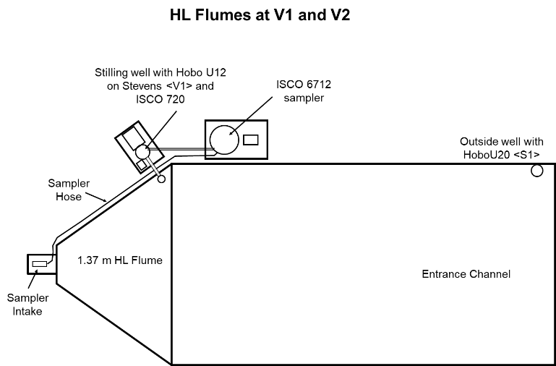

Figure 2. Locations of data collection points at the HL Flumes at V1 and V2. Outside well HOBO20 (Barometric measure and hydrometric pressure upstream, 2 divers). Downstream is HOBO U12 on Strevens.

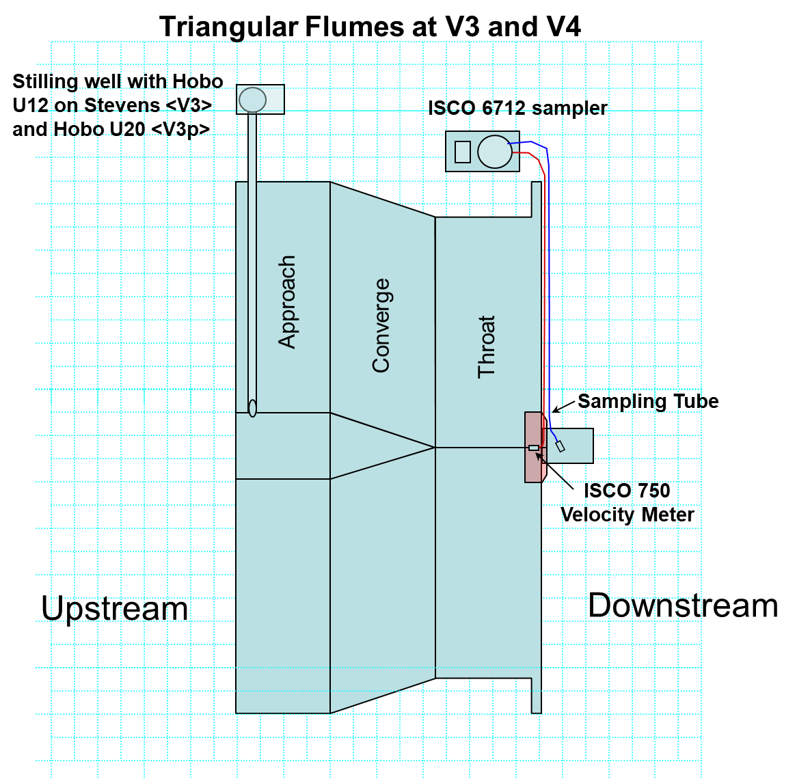

Figure 3. Locations of data collection points at the Triangular Flumes at V3 and V4.

Table 2. La corona instrumentation reading functions in <https://github.com/enervifa/lacorona>

| Station | n | | name | Equip | Script | File |
| --- | --- | --- | --- | --- | --- | --- |
| Flume | 4 | | V1,V2, V3,V4 | Hobou20 | x | read_files.R |
| ISCO | x |
|  | |  | StevensHobou12 | x |
| Automatic Well | 13 | | 13 (N3-N13) | Hobou (N1090418.csv) | x | read_files.R |
| Manual Well | 13 | | 13 | none |  |  |
| Weather Station | 1 | | 1 (EM) | EM090418.dat |  | FALTA WS |
| Automatic Rain gauge | 2 | | 2 (R1,R7) | Hobou (R1090418.csv) | Almost? | read_files.R  FALTAREM |
| Manual Rain gauge | 6 | | 6 (R2,R3,R4,R5,R6,RV1) | none |  | FALTA:  R1+EM |

| WS | 1 | WS | HOBOconnect |  |  |
| --- | --- | --- | --- | --- | --- |

## La Corona Instrumentation photos from the field visiting pasture V1 and pine V2 catchments 15062022

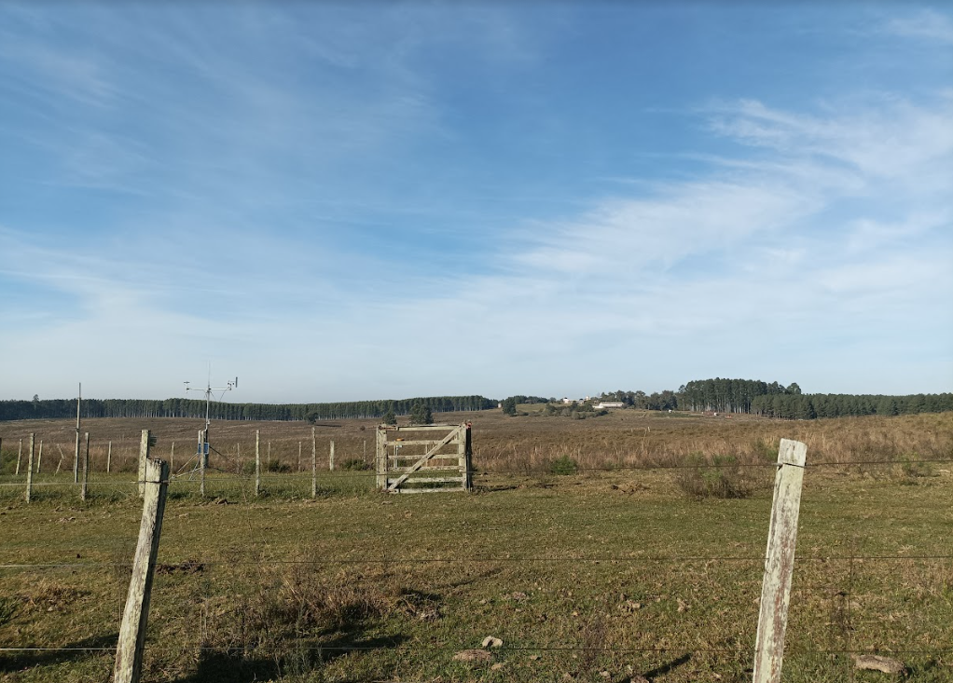

Figure 4. EM Weather Station

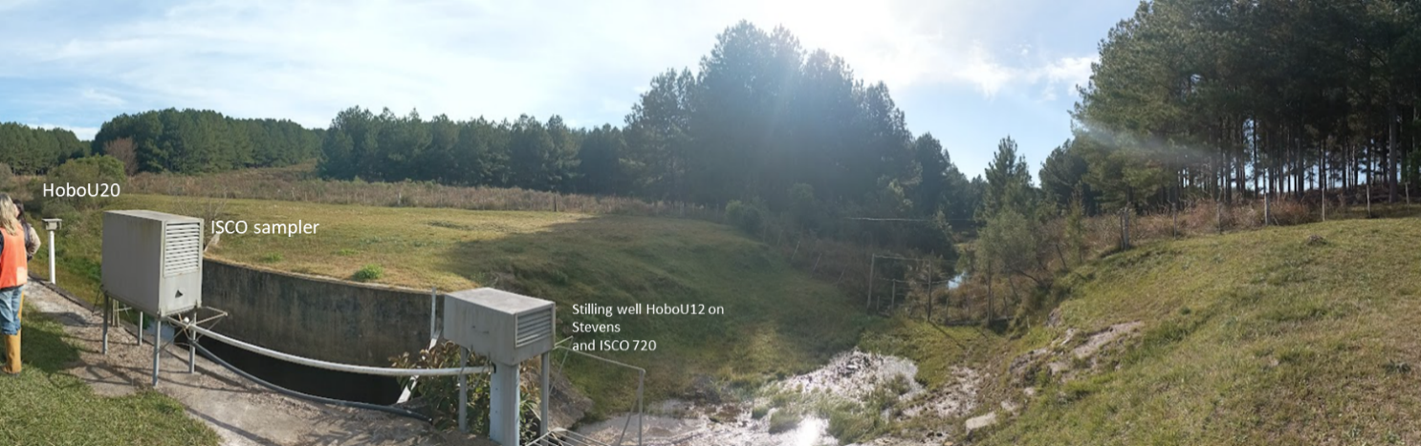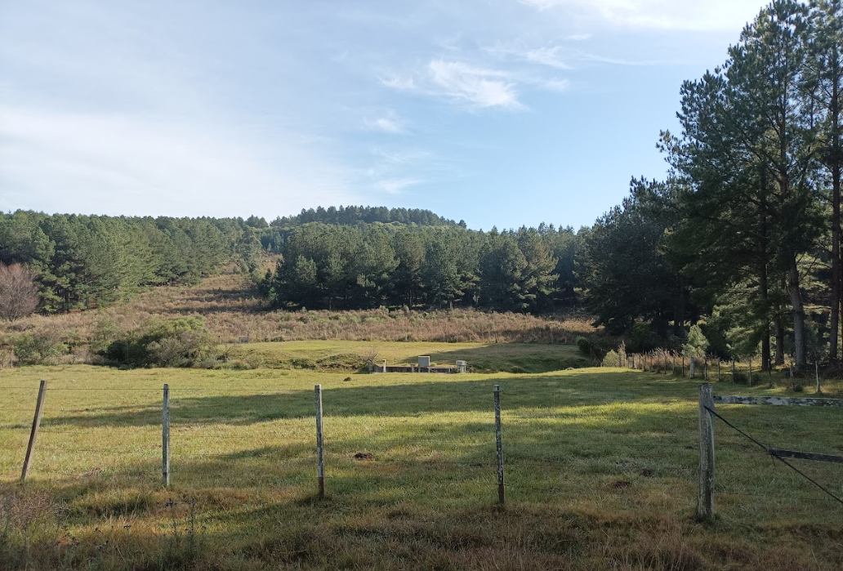

Figure 5. HL Flume at V2

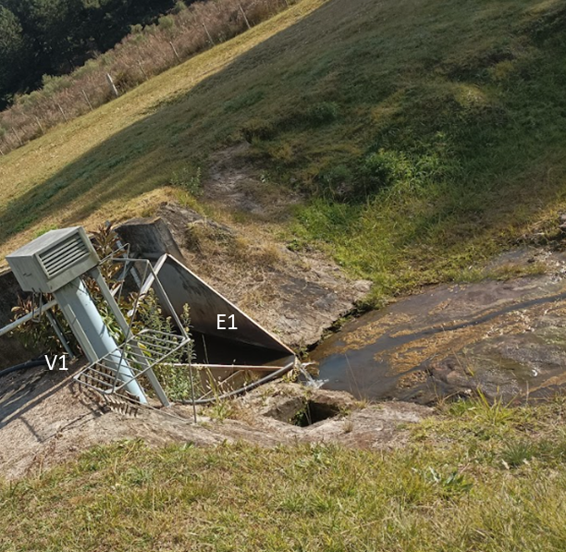

Figure 6. HL Flume at V2. Data: V1 - Stevens Recorder with Hobo U12 datalogger on potentiometer in stilling well. E1 - Emergency Spillway – Broad crested weir with U20 Hobo Pressure transducer in stilling wel

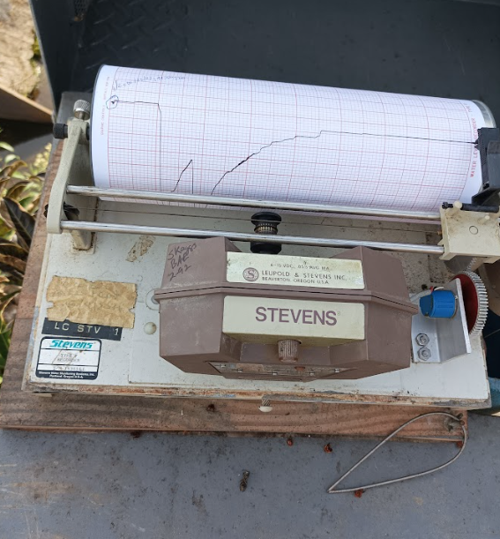 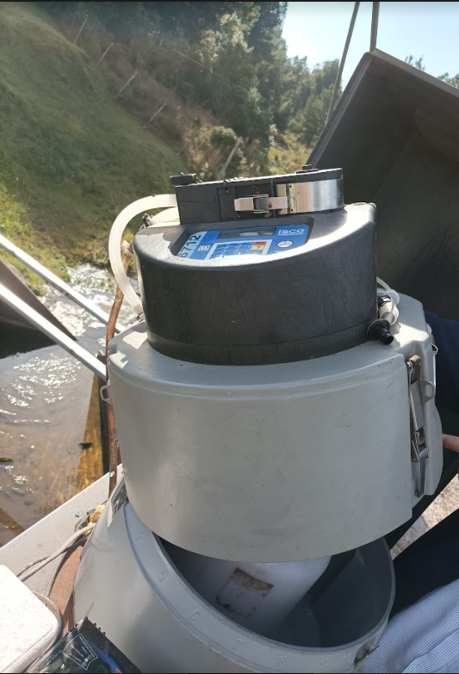

Figure 7. Stevens and ISCO sampler instruments in HL Flume at V2

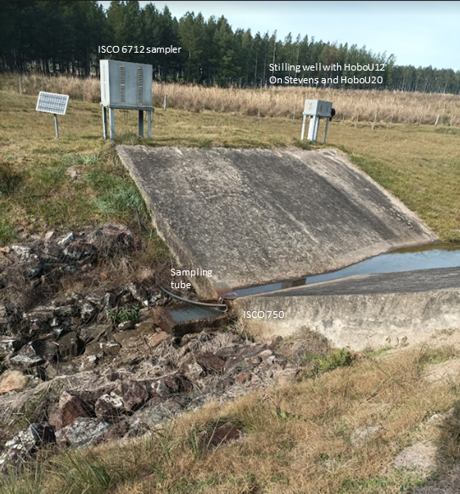

Figure 6. Triangular Flume additional at V1. Data: V3 - Stevens Recorder with Hobo U12 datalogger on potentiometer in stilling well , V3p - Hobo U20 Pressure transducer in stilling well, Barometric Pressure - Hobo U20 Pressure transducer in stilling well at elevation above highest potential water level.

Análisis de datos observados con el script **LCobsdata.Rmd**

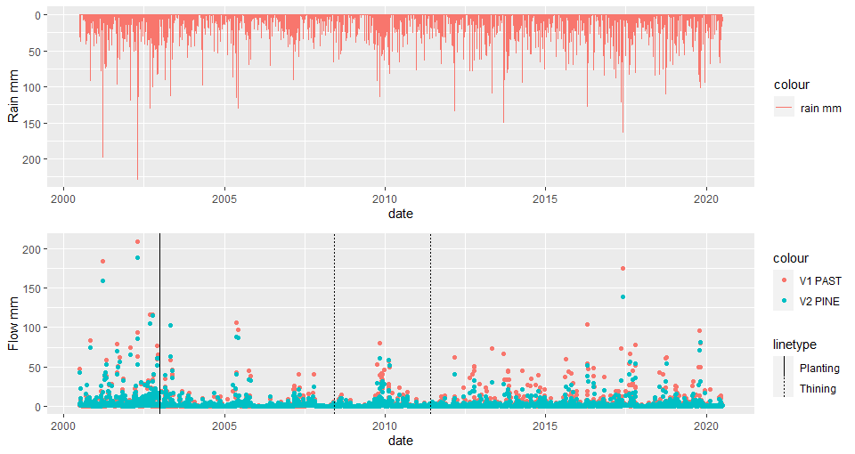

Figure 7. Hydrograph, daily series of rainfall and flow in both catchments with planting and thinning times

Analysis of FDC was adopted, as it has credibility and acceptance among many hydrological studies

FDC 2000-2020. Flow duration curve for the whole period - As 107 ha pines vs 69 ha pasture, the plot was done in millimetres in order to exclude area effect

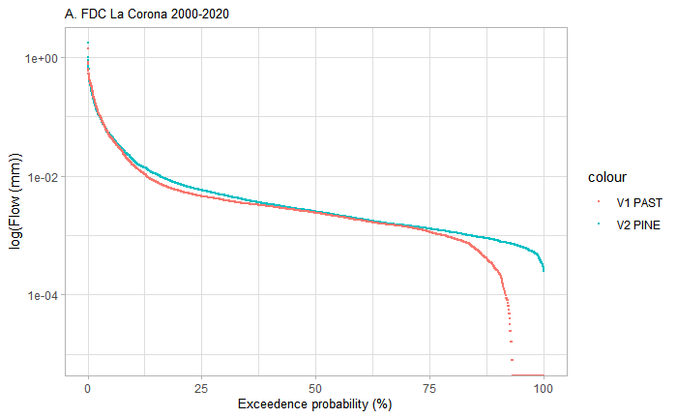

**Calibration period**

2000-2003

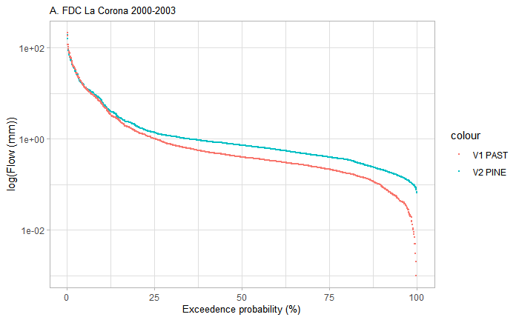

2000-2004 as Chip suggested including also 2004. This is because of high rainfall events in 2002 and 2003.

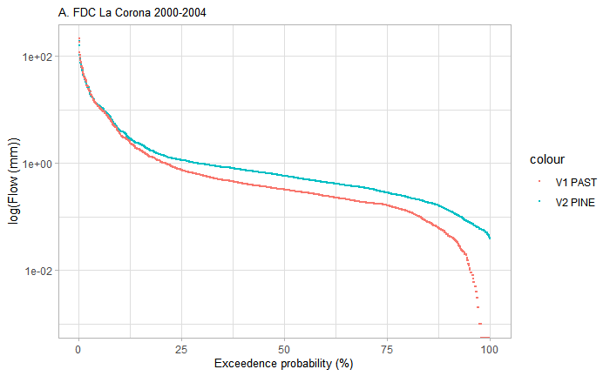

Looking at the different periods since planting (calibration, intermediate latter) a clear shift of the pine curve is observed to lower flow probabilities. The period influences the shape of the curve, two drought events occurred in the intermediate period (2007and 2008/2009)

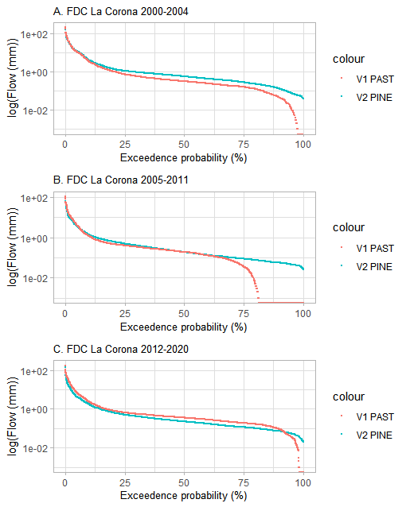

Plotting by semester period where significant ET was described (JA), only years after planting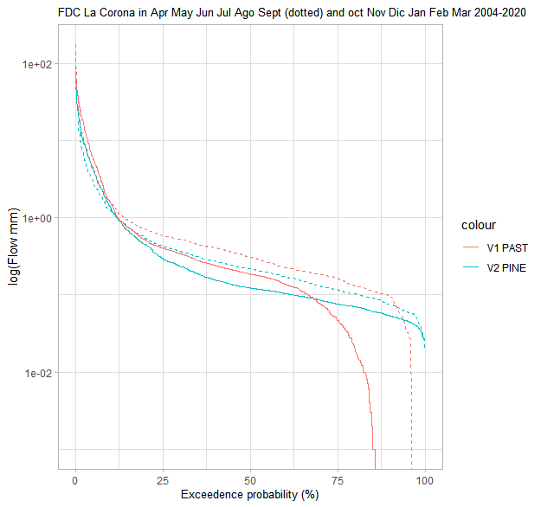

Following Jones et al 2016 results, we plotted Qref/Qmodif . Looking at the plot, we can observe that after the modification (planting), water yield in the modified watershed initially increases, followed by a persistent reduction after the second thinning. Its behaviour is similar to dashed curve D described by jones et al 2016.

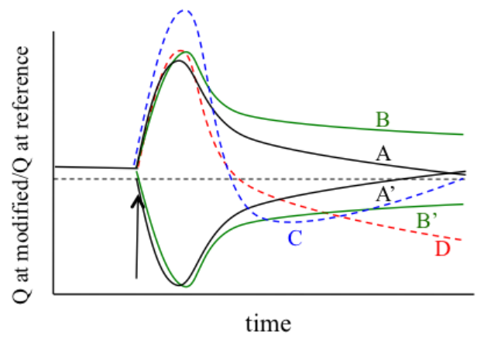

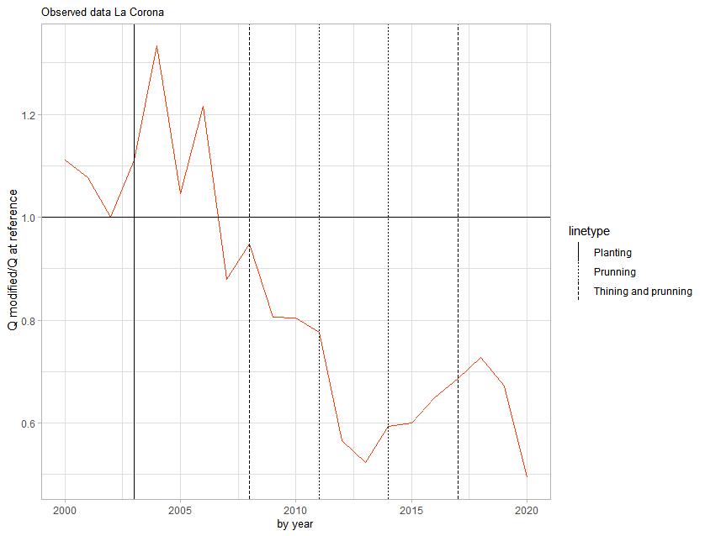

By month by year, and try to add a fitted regression model line (loess:locally weighted polynomial and linear), firstly excluding 3 months outliers when Qmodified/Qreference is 25, 16 and

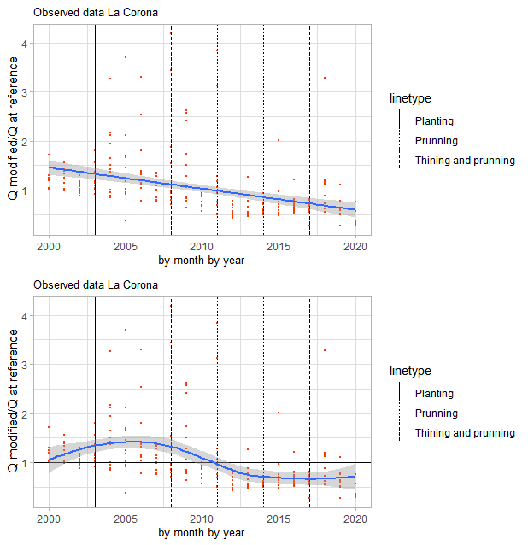

Annual runoff coefficient Q/P and rainfall relation. The difference between Q response increase after the second thinning. Lets see if we can observe an effect on an annual scale of the plantation treatment.

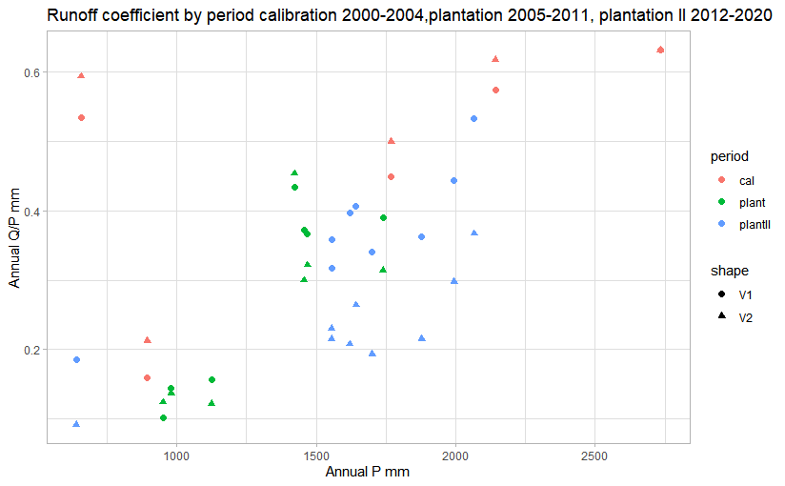

Further steps

-finish with the coding to analyse 6-month data for 2 PWE and compare with Chips outputs.

-meeting the second week of November

-Agustin and Eliana draft a budget of the 5 years sensor life

-we will work with info in the drive now, Eliana will start the conversation with INIA about the data storage process.

## Instrumentation check and methodology (April - June 2023)

Calibration once a year - rain gauges and sampler volume

The sampler samples 100 mL each time, collect the sampler and check the volume.

EM recalibration - send it to the manufacturer. We need to get a new wind speed/direction sensor. Also a new solar radiometer?

Recalibrate net-radiometer

All EM sensors are re-calibrated every 2 years

No calibration on HOBOs. The battery of U20s runs out and needs to be changed. The company does that, charging half of the loggers price. Proce 360 USD each

Wells sensors are about quantity of measurements

Flume sensors last 5 years

Sensors are going to bluetooth download - see this prices

ISCO are selling a new cable to connect the computer.

**Loggers: Flumes - HoboU20, ISCO, Stevens HoboU12**

Stevens at this time is a backup (third measurement). La Corona Stevens recorders with potentiometers, Currently an electronic measurements. Charts are really no good, response is too quick acting as a pulley system.

Hobo U20 in the stilling well, **these are newer.**

**The U12 Hobo's are outdated and are no longer made**. Possibly replace the logger. Alternatively is replace the whole thing with a pressure transducers. To replace U12 would need a logger to measure the resistance. At that time, the Stevens were more accurate then the pressure transducers. Campbell loggers could be a replacement, but are expensive.

Flumes 3 & 4, pressure transducer is in the same well as the Stevens: Hobo U20

**ISCO velocity measurement could be moved further upstream for a better measurement**

H flumes are not as accurate for the low flows

**U20's every 5 years they need a battery change, but Chip thinks this was done recently**. Two types of U20s, one is plastic (cheaper) and one is stainless ($600), no real difference according to Chip. Plastic hobos are also in the groundwater wells. There are also extra barometric pressure (2 officially)

**The ISCOS are getting old. There are two extra ones (one might be essentially new)**. There are three that have been there almost 20 years, the other three came in later. The oldest are V1 and V2. If possible it would be good to get 2 spares.

V1 and V2: Extra pressure transducer is in a separate well, sometimes there is a lot of sedimentation and this plugs the stilling well hole and then the extra well is better.

Weather station. Wind speed and direction is bad, needs recalibrated and replaced. Radiation needs recalibration? Raingauge is working independently, probably more accurate.

New data

**plot of three different methods and compare those "one that looks best"**

mass balance? knowing the average rainfall runoff coefficient?

Mostly two of the match or obvious which one is not correct

one of the loggers might just show bad data: high variation?

also taking a measurement in the field every time there is a download use this to check everything is starting and stopping at the right time

Can calculate the volumes from the stage relationship in the flume

Stage discharge relationship from the flume.

Chip has relationships between the different measurements

Relationships between the stilling well and the velocity meter and the stages

Potentially cameras $89.99<https://www.spypoint.com/en/products/cellular-trail-camera/product-flex.html>

Data form Chip June 2023

The data are on SampleFiles2. They cover a wet four week period in October/November of 2019 (10/18/19 to 11/12/19). The flumes, weather station, and rain gauges were downloaded two times (11/01 and 11/12) and the wells were downloaded once (11/12). During some heavy storms, flow occurred in the emergency spillways at V1 and V2. I included some spreadsheets of combined data sets from July 1, 2019 to December 31, 2019 that show how I compare the data and use the manually collected data to adjust and verify the data. The manual data are recorded in the "Planilla cuenca ***.doc" files located in the Wells/Manual directory. You might want to purchase the Hoboware Program from Onset (<https://www.onsetcomp.com/products/software/hoboware>). This program converts the .Hobo files that are downloaded in the field to .cvs files. You will need the Pro version to use with the U20 hobos

Data processing

**Wells**

Excel from Chip, data from logger in Level (m) is transformed to WTD(m) using autowell measures. Do they have topographic height ? This is to convert to piezometric height. Ask this to Chip

## Annex

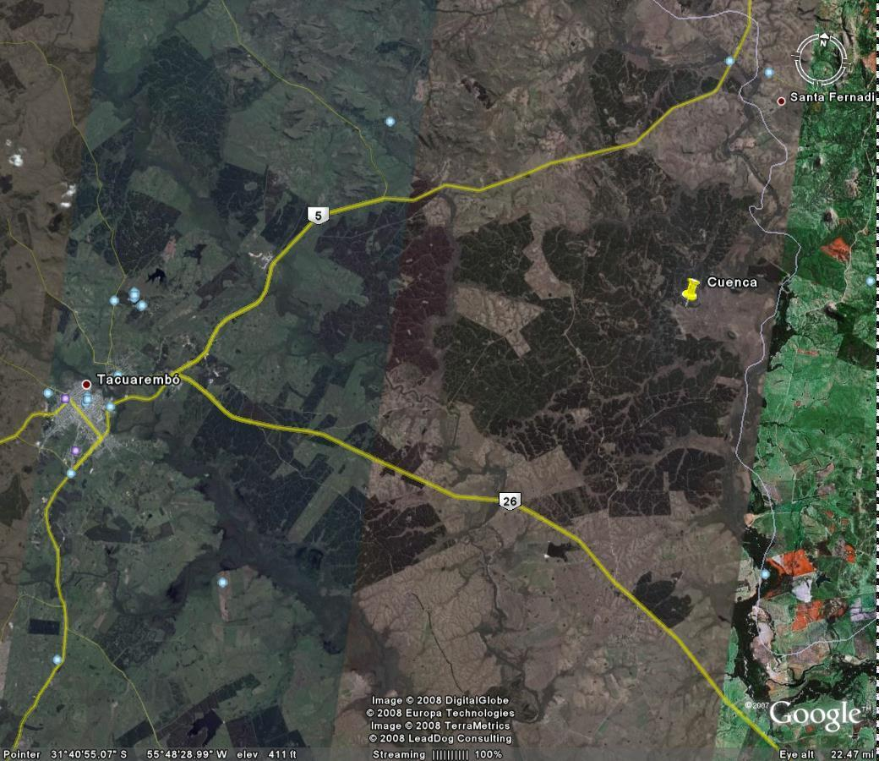

Figure A1. UruguaySite2

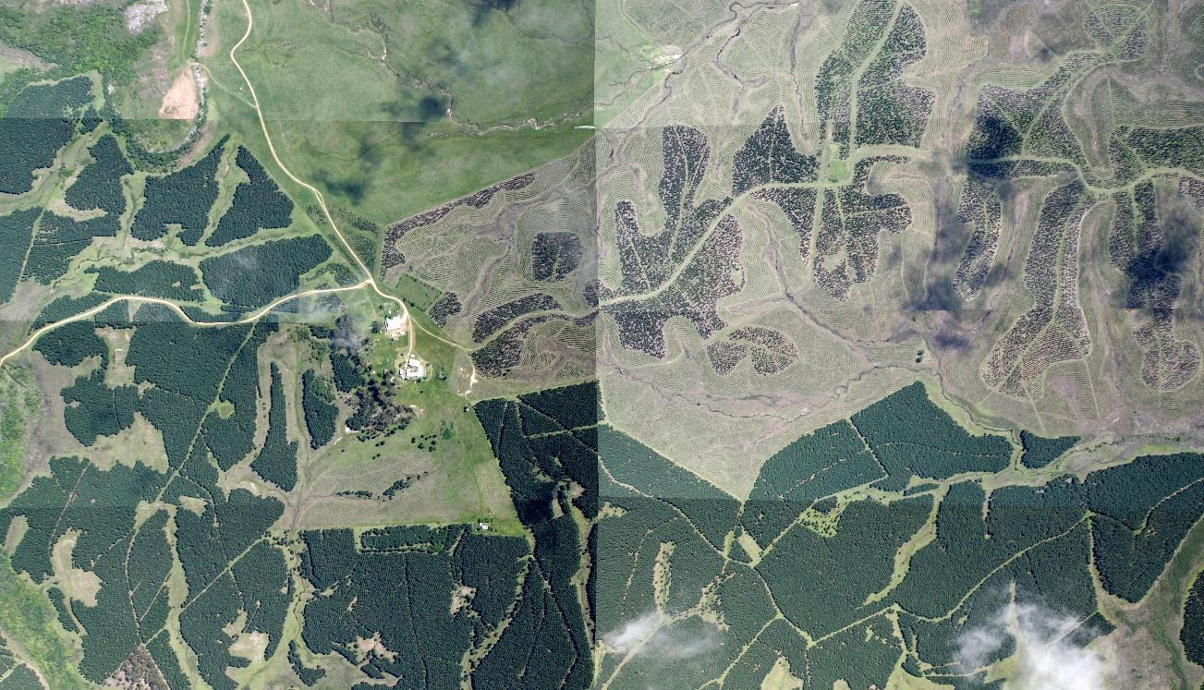

Figure A2. La_Corona_Subzona_B1

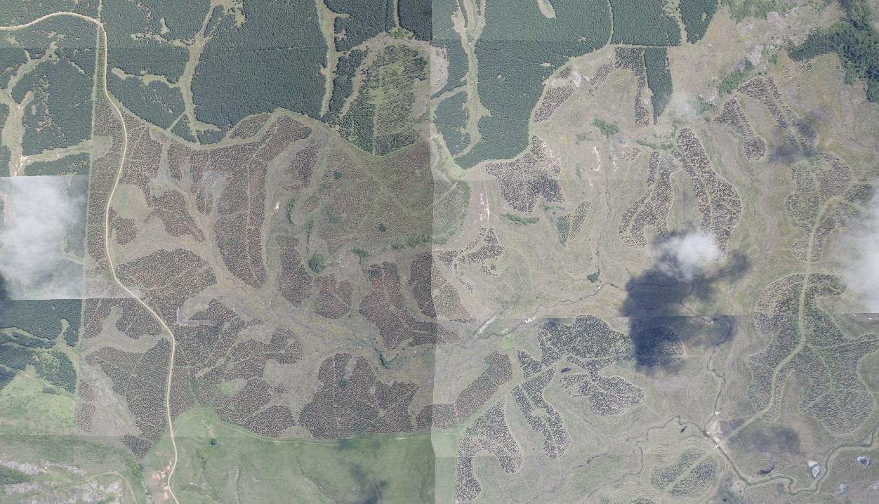

Figure A3. La_Corona_Subzona_A1

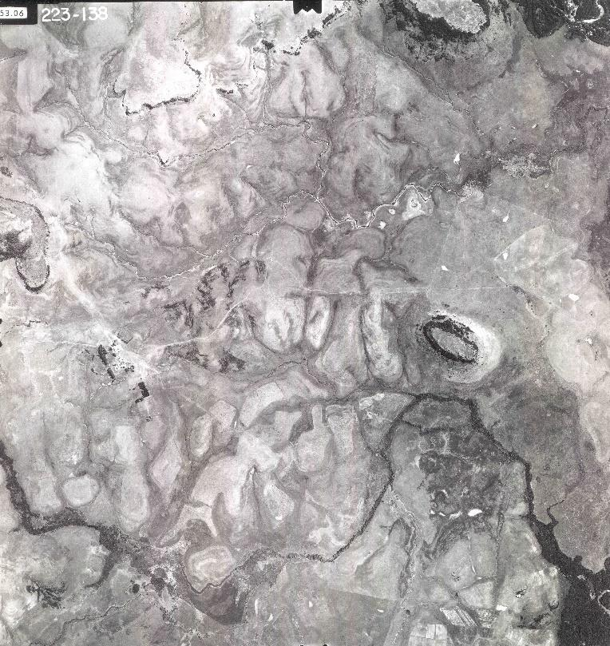

Figure A4. FotoCorona_223 138b

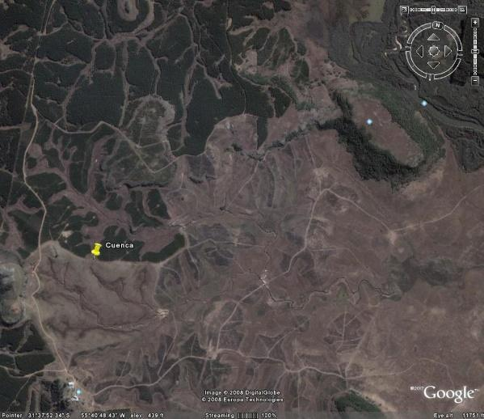 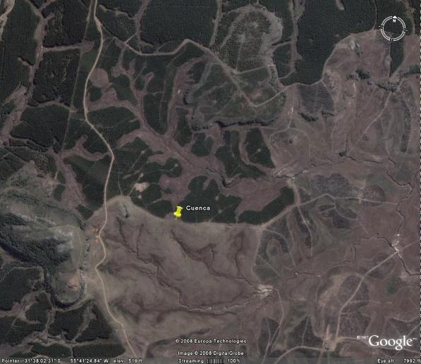

Figure A5. UruguaySite1

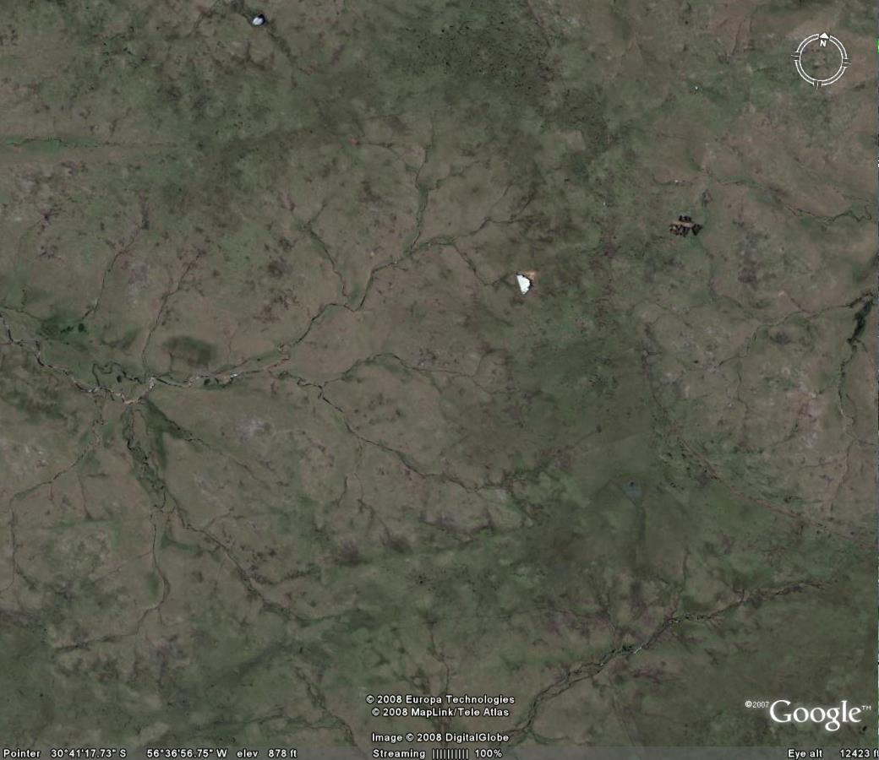 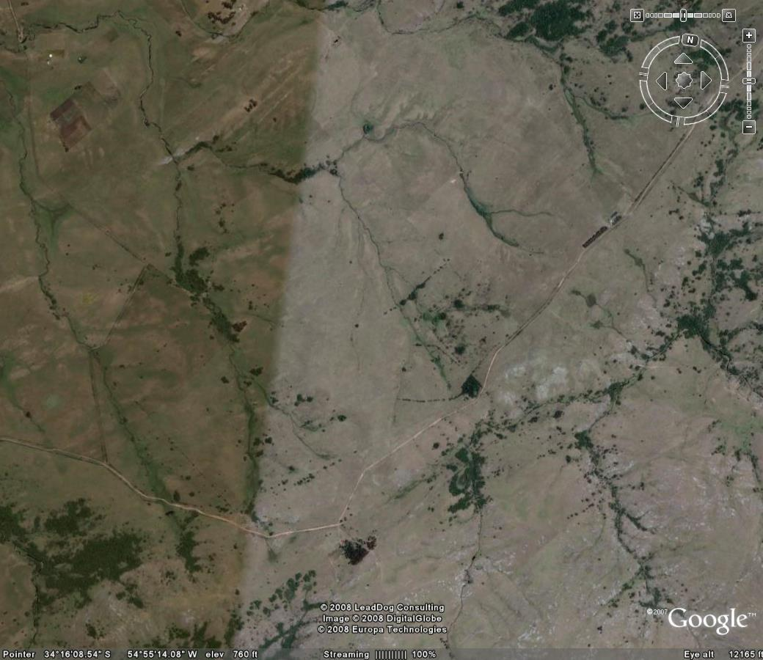

Figure A6. Cuencap1 and Cuencap2 2008